**CONNECTIONS IN WOKWI FOR ULTRASONIC SENSOR**

**CODE:**

**Sketch.ino:**

**/\***

**Ultrasonic Simple**

**Prints the distance read by an ultrasonic sensor in**

**centimeters. They are supported to four pins ultrasound**

**sensors (liek HC-SC04) and three pins (like PING)))**

**and Seeed Studio sensors).**

**The circuit:**

**\* * Module HR-SC04 (four pins) or PING))) (and other with**

**three pins), attached to digital pins as follows:**

**--------------------- --------------------**

**| HC-SC04 | Arduino | | 3 pins | Arduino |**

**--------------------- --------------------**

**| Vcc | 5V | | Vcc | 5V |**

**| Trig | 12 | OR | SIG | 13 |**

**| Echo | 13 | | Gnd | GND |**

**| Gnd | GND | --------------------**

**---------------------**

**\*/**

**#include "Ultrasonic.h"**

**/\***

**Pass as a parameter the trigger and echo pin, respectively,**

**or only the signal pin (for sensors 3 pins), like:**

**Ultrasonic ultrasonic(13);**

**\*/**

**Ultrasonic ultrasonic(12, 13);**

**int distance;**

**void setup() {**

**Serial.begin(9600);**

**}**

**void loop() {**

**// Pass INC as a parameter to get the distance in inches**

**distance = ultrasonic.read(CM);**

**Serial.print("Distance in CM: ");**

**Serial.println(distance);**

**distance = ultrasonic.read(INC);**

**Serial.print("Distance in Inches: ");**

**Serial.println(distance);**

**delay(1000);**

**}**

**Diagram.json:**

{

  "version": 1,

  "author": "Keesarapalli keerthi",

  "editor": "wokwi",

  "parts": [

    { "type": "wokwi-arduino-uno", "id": "uno", "top": -17.73, "left": 26.12, "attrs": {} },

    { "type": "wokwi-hc-sr04", "id": "ultrasonic1", "top": -152.2, "left": -13.93, "attrs": {} }

  ],

  "connections": [

    [ "ultrasonic1:VCC", "uno:5V", "red", [ "v22.94", "h-51.93", "v236.03", "h180.99" ] ],

    [ "ultrasonic1:TRIG", "uno:12", "green", [ "v31.34", "h95.05" ] ],

    [ "ultrasonic1:ECHO", "uno:13", "green", [ "v24.81", "h75.96" ] ],

    [ "ultrasonic1:GND", "uno:GND.1", "black", [ "v19.21", "h54.08" ] ]

  ]

}

**OUTPUT:**

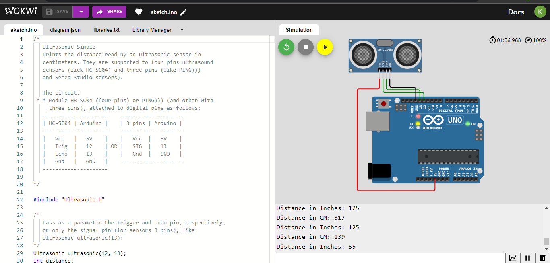

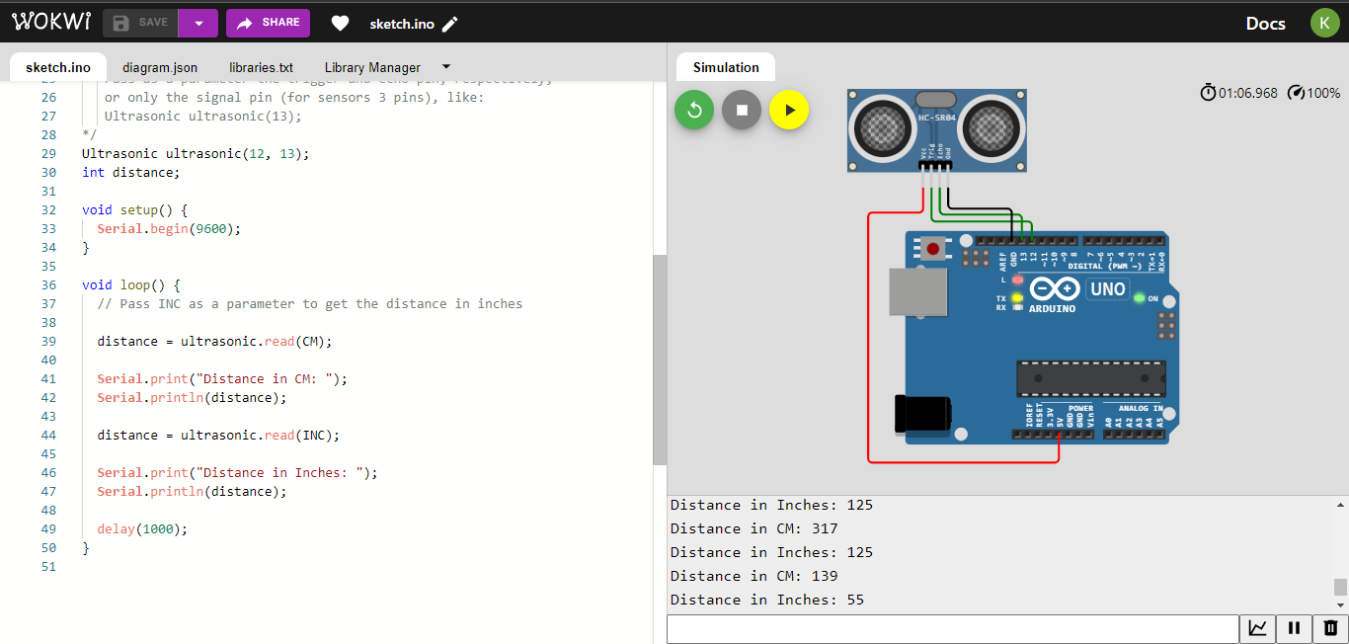

**LINK:** https://wokwi.com/projects/348454054394856020